**Exploring Associations Between the Internet Access and Sustainable Economic Development indicators: a Country-Level Study**

Bus Analytics for Managers

Section V01

Team Wolverine

Yuge Ma

Wanshan Mao

Muhetaer Mayila

Owakhela Kankhwende

5/3/2021

|  |  |  |  |  |  |  |
| --- | --- | --- | --- | --- | --- | --- |
| # | Hypothesis | Question | Analytic type | Variable(s) | Chart | Conclusion (later) |
| 1 | If the number of mobile cellular subscriptions increase, the amount of current health expenditures decrease. | Is there a negative correlation between the number of mobile cellular subscriptions and the amount of current health expenditures? | Descriptive | Mobile cellular subscriptions, Current health expenditures per capita | Figure1: Bar chart | There was no association between the number of mobile cellular subscriptions and the amount of current health expenditures. |
| 2 | If the percentage of individuals using the internet increases, the percentage of school enrollment increases. | Is there a positive correlation between the percentage of individuals using the internet and the percentage of school enrollment? | Descriptive/Predictive | Individuals using the internet, School enrollment | Figure2: Line chart (with trend line) | Increased percentage of school enrollment did not necessarily mean increased percentage of individuals using the internet. |
| 3 | If the number of internet access increases, the amount of current healthcare expenditure increases | Is there a positive correlation between the individuals using the internet and the amount of current healthcare expenditure | Descriptive/Predictive | Individuals using the internet, Current healthcare expenditure | Figure3: Scatter plot (with trend line) | There was a positive correlation between the individuals using the internet and the amount of current healthcare expenditure. |
| 4 | If fixed telephone subscriptions increase, GNI per capita increases. | As there are more fixed telephone subscriptions, have more people utilized the internet to increase their GNI per capita? | Descriptive | Fixed telephone subscriptions, GNI per capita | Figure 4: Tree map | The results were mixed. On average as some countries had higher fixed telephone subscriptions, and so larger internet access. |
| 5 | If the percentage of computer, communications and other services imports increase, the GDP per capita decreases. | What is the relationship between computer imports and GDP? | Descriptive | Computer, communication and other services imports, GDP per capita | Figure 5: Histogram chart | There was a negative relationship between computer imports and GDP per capita. |
| 6 | If the number of fixed telephone subscriptions increase, the percentage of unemployment increases. | Is there a positive correlation between the number of Fixed telephone subscriptions and the percentage of Unemployment? | Descriptive/predictive | Fixed telephone subscriptions, Unemployment | Figure 6: Scatter plot  (with trend line) | There was a negative correlation between the number of Fixed telephone subscriptions and the percentage of Unemployment. |
| 7 | If the number of Individual using the internet increases, the percentage of unemployment increases. | Is there a positive correlation between the number of Individual using the internet and the percentage of Unemployment? | Descriptive/predictive | Individual using the internet, Unemployment | Figure 7: Line chart (with trend line) | There was no significant relationship between the number of Individual using the internet and the percentage of Unemployment. |
| 8 | If the number of fixed broadband subscriptions increase, the number of GDP per capita increases. | Is there a positive correlation between the number of Fixed broadband subscriptions and the number of GDP per capita? | Descriptive/predictive | Fixed broadband subscriptions, GDP per capita | Figure 8: Polygon chart (with trend line) | There was a positive correlation between the number of Fixed broadband subscriptions and the number of GDP per capita. |
| 9 | If the number of secure internet servers increase, the number of GNI per capita increases. | Is there a positive correlation between the number of Secure internet servers and the number of GNI per capita? | Descriptive/predictive | Secure Internet servers, GNI per capita | Figure 9: Area chart (with trend line) | There was a positive correlation between the number of Secure internet servers and the number of GNI per capita. |
| 10 | If the mobile cellular subscription increases, GNI per capita increases. | Can the estimated mobile cellular subscriptions predict GNI per capita? | Predictive | Mobile cellular subscriptions, GNI per capita | Figure 10:  Dual lines | The trend of GNI per capita was predicted by the estimated mobile cellular subscription. |
| 11 | If the mobile cellular subscription increases, GNI per capita increases. | Do GNI per capita and mobile cellular increase in time series? | Descriptive/predictive | Mobile cellular subscriptions, GNI per capita, Year | Figure11:  Side by side circles | GNI per capita and mobile cellular increased in time series. |
| 12 | If the number of individuals using the internet increases, GDP per capita increases. | Can the estimated number of individuals using the internet predict GDP per capita? | Predictive | Individual using the internet, Unemployment, Year | Figure 12:  Dual combination | The trend of GDP per capita was predicted by the estimated number of individuals using the internet. |
| 13 | If the number of individuals using the internet increases, GDP per capita increases. | Do developed countries have a higher number of individuals using the internet and GDP per capita? | Descriptive | Individual using the internet, Unemployment, Country name | Figure 13:  Horizontal bar | Developed countries had higher numbers of individuals using the internet and GDP per capita. |
| 14 | If the number of secure servers increases, the number of unemployment rate decreases | Is there a negative correlation between the number of secure internet servers and unemployment rate? | Descriptive | Secure Internet servers, Unemployment total | Figure 14:  Tree map | More secure internet servers, the less unemployment rate, which could be explained by if a country has enough secure internet servers, there would be more job opportunities. |
| 15 | If the number of average percentages of individuals using the internet increases, the number of school enrollment increases. | Is there a positive correlation between the individuals using the internet and the number of school enrollment? | Descriptive | Individuals using the Internet, School enrollment | Figure 15:  Symbol map (clustered) | The findings suggested that education is strongly linked to technology development. The government should focus on both education and technology development in order to achieve both improvement. |
| 16 | If the number of computer communications and other services increases, the number of unemployment decreases. (In time series) | Is there a negative correlation between the computer communications and other services and unemployment? | Descriptive | Year, computer communications and other services, Unemployment | Figure 16:  Dual lines chart | The chart indicated that there is a negative relationship between Computer communications and other services and Unemployment total. |
| 17 | If the number of fixed broadband subscriptions increase, the number of GNI per capita increases. | Is there a positive correlation between the number of fixed telephone subscriptions and the number of GNI per capita? | Descriptive | GNI per Capita, Fixed broadband subscriptions | Figure 17: Area chart | An increase in fixed broadband subscriptions was inversely related to GNI per capita. |
| 18 | If Individuals Using the Internet increase, Current Healthcare expenditure Increases | Is the prevalence of internet capable products positively correlated with healthcare expenditure | Descriptive | Individuals using the internet, Current healthcare expenditure, Country Name | Figure 18: Symbol map bar chart | A close relationship was not easily identifiable between the variables. |
| 19 | If Fixed telephone subscriptions increases, Current Healthcare expenditure is higher | Is Internet access positively correlated with healthcare expenditure? | Descriptive | Mobile Cellular Subscriptions, Current healthcare expenditure, Country Name | Figure 19: Bubble chart | A close relationship was not easily identifiable between the variables. In fact some countries far behind in current healthcare expenditure were ahead in fixed telephone subscriptions. |
| 20 | If Computer and other Services Imports increases, School Enrollment increases | Is there a positive relationship between computer and other services imports and school enrollment? | Descriptive | Computer, communication and other services imports, School enrollment | Figure 20:  Side by side bars | There was no significant relationship between computer communication and other service imports and school enrollment. |
| 21 | If Fixed Broadband Subscriptions, Fixed Telephone Subscriptions and Mobile Cellular Subscriptions Increase - GDP per capita Increases | As broad internet access increases, does the GDP per capita increase? | Predictive Statistical Model | Fixed Broadband Subscriptions, Fixed Telephone Subscriptions, Mobile Cellular Subscriptions. GDP per capita Increases | Figure 21:  Multiple Regression | The chart indicated a small positive Pearson correlation between Fixed Broadband Subscriptions and GDP per capita as well as Fixed Telephone Subscriptions. Mobile Cellular Subscriptions had a smaller negative Pearson correlation. |
| 22 | If the Proportion of Individuals using the Internet is similar from country to country, the economic indicators are likely to be similar | Does the proportion of individuals using the internet result in a similar economic outcome? | Predictive Machine Learning Model | Individuals using the Internet,  GDP per Capita | Figure 22:  K Means | The chart indicated that there was a positive relationship between individuals using the Internet and GDP per capita. If more people used the Internet, it would boost the GDP |

Figure 1 Bar chart of mobile cellular subscriptions/current health expenditures per capita – Muhetaer Mayila

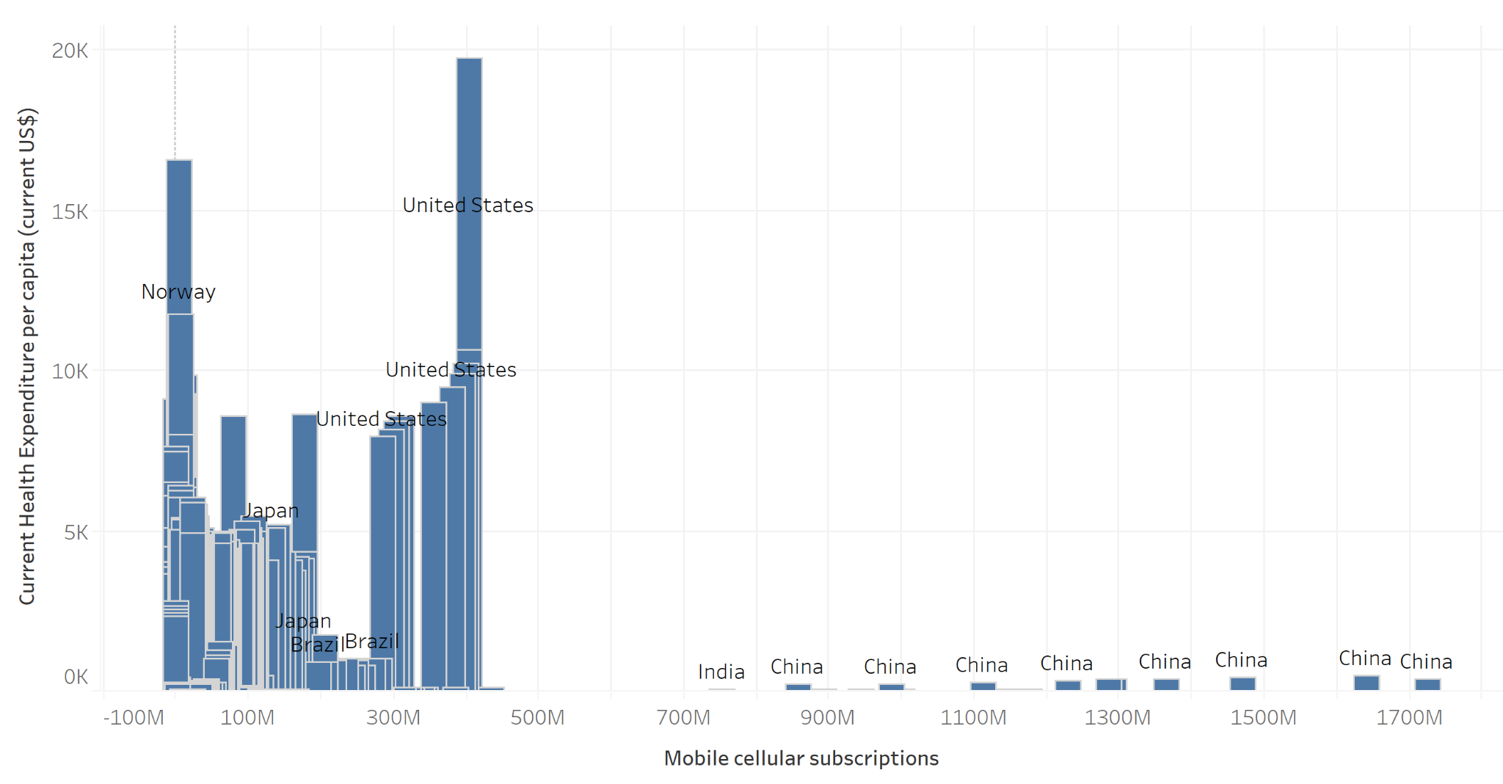

Figure 1 Bar chart of mobile cellular subscriptions/current health expenditures per capita – Muhetaer Mayila

* Figure 1 displayed a bar chart where the x-axis represented the number of mobile cellular subscriptions and the y-axis represented the current health expenditures per capita.
* The chart did not indicate a clear association between the two variables. For example, United States and China’s mobile cellular subscriptions increased when their current health expenditures increased. But Brazil and Japan’s mobile cellular subscriptions increased when their current health expenditures decreased.
* The findings suggested that World Leaders should not only focus on the growth of internet technologies, but could invest their resources more in the health care area.

Figure 2 Line chart of the percentage of individuals using the internet/ the percentage of school enrollment –Yuge Ma

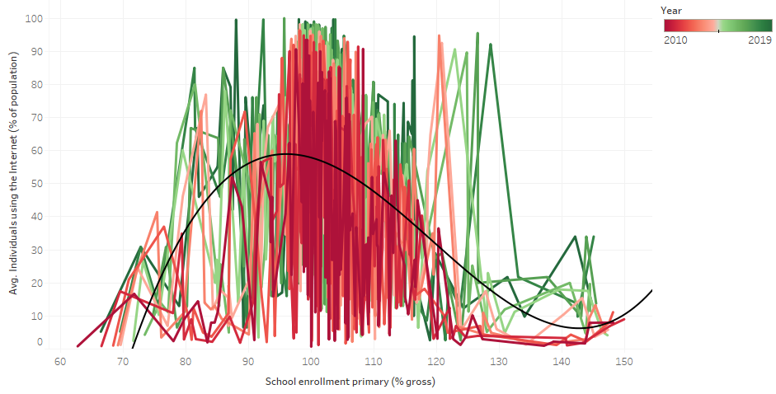

Figure 2 Line chart of the percentage of the percentage of individuals using the internet/ school enrollment –Yuge Ma

* Figure 2 displayed a line chart where the x-axis showed the percentage of school enrollment, and the y-axis showed the average percentage of individuals using the internet.
* The chart indicated the average percentage of individuals using the internet increased when the percentage of school enrollment increased at the beginning, then when the percentage of enrollment reached the range of 95% to 100%, the average percentage of individuals using the internet decreased when the percentage of school enrollment increased.
* The findings suggested that increased percentage of school enrollment did not necessarily mean increased percentage of individuals using the internet. The trend line in this line chart showed that these two variables fit into a nonlinear relationship, which in this case was polynomial regression.

Figure 3 Scatter Plot of percentage of individuals using the Internet and Current health expenditure -Yuge Ma

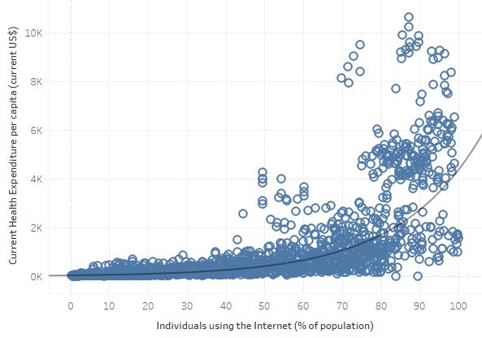

Figure 3 Scatter Plot of percentage of individuals using the Internet and Current health expenditure -Yuge Ma

* Figure 3 displayed a Scatter Plot chart where the x-axis showed the percentage of individuals using the Internet in population, and the y-axis showed the current health expenditure per capita.
* The chart indicated a positive relationship between the variables, with the increased percentage of individuals using the internet, the current health expenditure increased as well.
  + It also had an exponential relationship between the two variables, the r-squared was 0.75, the P value was less than 0.0001.
* The findings suggested that if the government spends more money on health expenditure for their citizens, the percentage of individuals using the Internet is high as well.

Figure 4 Tree Map of Fixed telephone subscriptions and GNI per capita - Owakhela Kankhwende

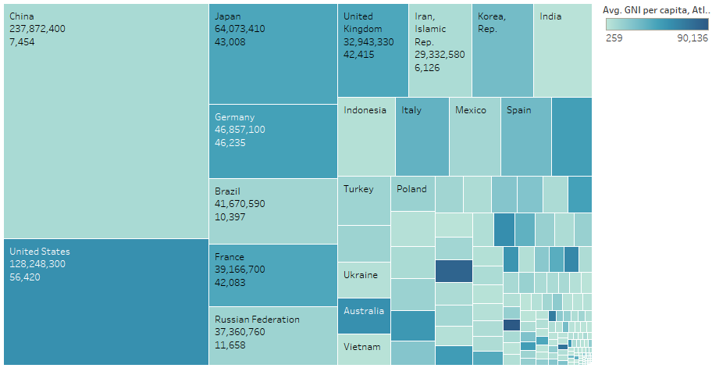

Figure 4 Tree Map of Fixed telephone subscriptions/GNI per capita - Owakhela Kankhwende

* Figure 4 displayed a Tree Map where the Size of the block represented Fixed telephone subscriptions and Color represented GNI per capita. Each block represented the average Fixed Telephone Subscription and average GNI per capita for each country over the ten years of the dataset.
* The chart indicated some positive correlation between the two variables, but this was disrupted by some major instances where the correlation was not so strong. Therefore, there may be a strong link between the two variables, but GNI per capita explanatory forces can vary so wildly that the link may not hold true in most cases.
* The findings suggested that governments should focus on the link between internet access and GDP for economics rather than GNI due to the mixed nature of the results . They should seek other factors that more directly associate with GNI for affecting GNI.

Figure 5 Histogram of Computer, communication and other services % import/ GDP per capita - Wanshan Mao

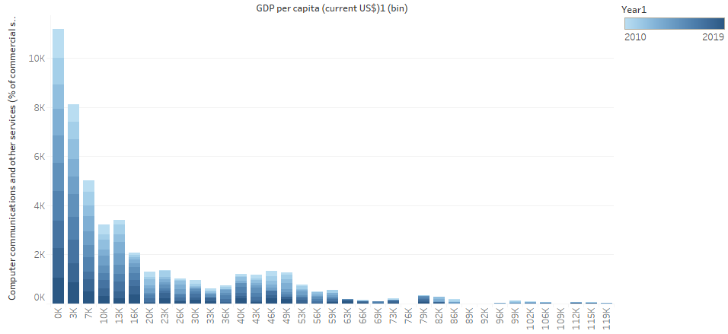

Figure 5 Histogram of Computer, communication and other services % import/ GDP per capita - Wanshan Mao

* Figure 5 displayed a histogram where the x-axis showed the average of GDP per capita, and the y-axis showed the computer, communication and other services % import.
* The chart indicated that as GDP per capita increased, computer import decreased. There was a negative correlation between computer, communication and other services % import.
* The findings suggested that when a country required less imports for computers and other services, the GDP per capita was growing.

Figure 6 Scatterplot of Fixed telephone subscriptions/Unemployment – Muhetaer Mayila

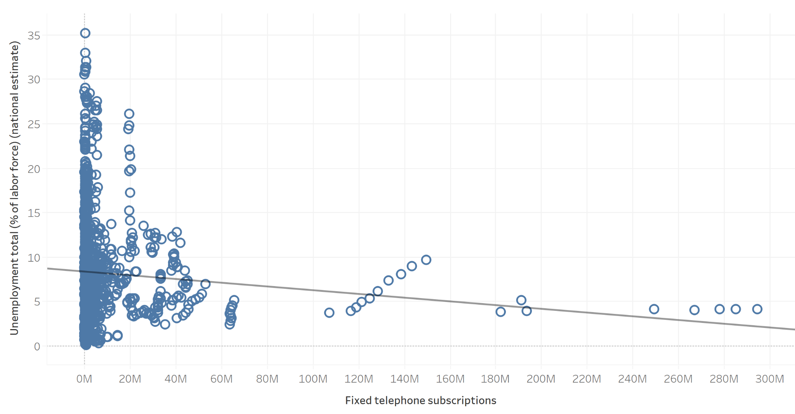

Figure 6 Scatterplot of Fixed telephone subscriptions/Unemployment – Muhetaer Mayila

* Figure 6 displayed a scatter plot where the x-axis represented the number of Fixed telephone subscriptions and the y-axis represented the amount of Unemployment.
* The chart indicated that there was a negative correlation between the number of Fixed telephone subscriptions and the amount of Unemployment. Even when R-squared was low, low P values still indicated a real relationship between the two variables.
  + The P value was 0.0025111 which was smaller than 0.05, and a R squared value of 0.007825.
* The findings suggested that countries should focus on providing more job opportunities to decrease the Unemployment population, so that the number of individuals who work will increase, as well as the economic production.

Figure 7 Line chart of Individual using the internet/Unemployment – Muhetaer Mayila

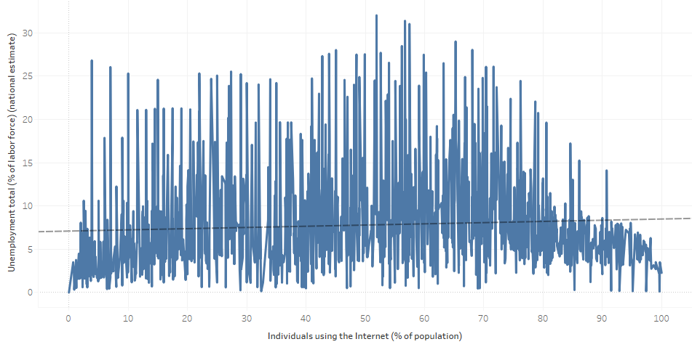

Figure 7 Line chart of Individual using the internet/Unemployment – Muhetaer Mayila

* Figure 7 displayed a line chart where the x-axis showed the number of Individual using the internet, and the y-axis showed the percentage of the labor force that is Unemployment.
* The chart did not indicate that there is an association between the number of Individual using the internet and the percentage of the labor force that was Unemployment.
  + The P value is 0.166043 which was greater than 0.05, and R square was 0.0015667.
* The findings suggested that countries should not only focus on the growth of the internet, but also try to provide more job opportunities to decrease the Unemployment population.

Figure 8 Polygon chart of Fixed broadband subscriptions/GDP per capita -Muhetaer Mayila

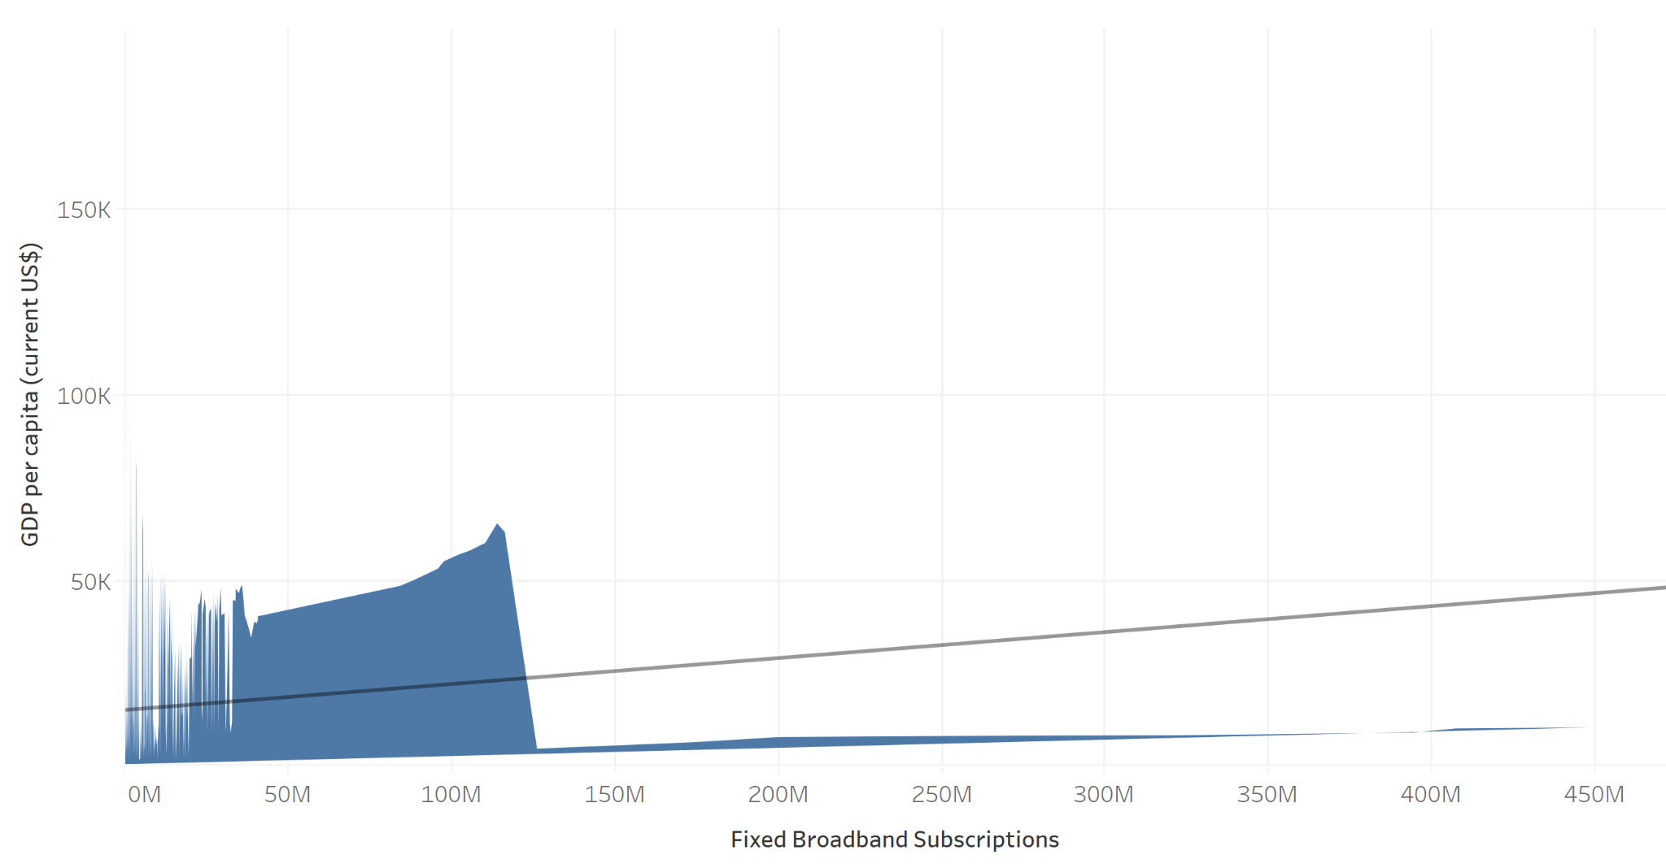

Figure 8 Polygon chart of Fixed broadband subscriptions/GDP per capita -Muhetaer Mayila

* Figure 8 displayed a polygon chart where the x-axis showed the number of Fixed broadband subscriptions, and the y-axis showed the number of GDP per capita.
* The chart indicated that there was a positive correlation between the number of Fixed broadband subscriptions and the number of GDP per capita. Even when R-squared was low, low P values still indicate a real relationship between the two variables.
  + The P-value was less than 0.0001, and a R squared value of 0.0105781.
* The findings suggested that countries could focus more on the growth of GDP per capita, since faster growth in gross domestic product (GDP) expanded the overall size of the economy.

Figure 9 Area chart of Secure Internet servers/ GNI per capita – Muhetaer Mayila

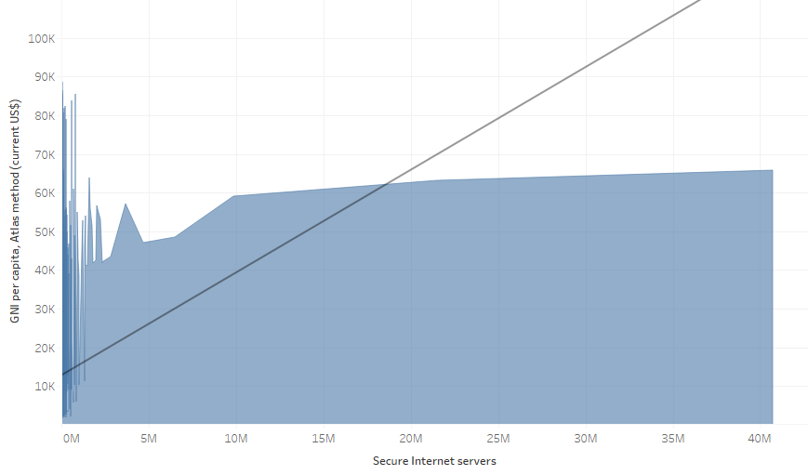

Figure 9 Area chart of Secure Internet servers/ GNI per capita – Muhetaer Mayila

* Figure 9 displayed an area chart where the x-axis showed the number of Secure internet servers, and the y-axis showed the number of GNI per capita.
* The chart indicated that there was a positive relationship between the number of Secure internet servers and the number of GNI per capita. Even when R-squared was low, low P values still indicate a real relationship between the two variables.
  + The P-value was smaller than 0.0001, and a R square value of 0.02946.
* The findings suggested that GNI per capita did not affect a complete country’s level of development, but it could be a useful indicator.

Figure 10 Dual lines of Mobile Cellular Subscriptions and GNI per capita - Wanshan Mao

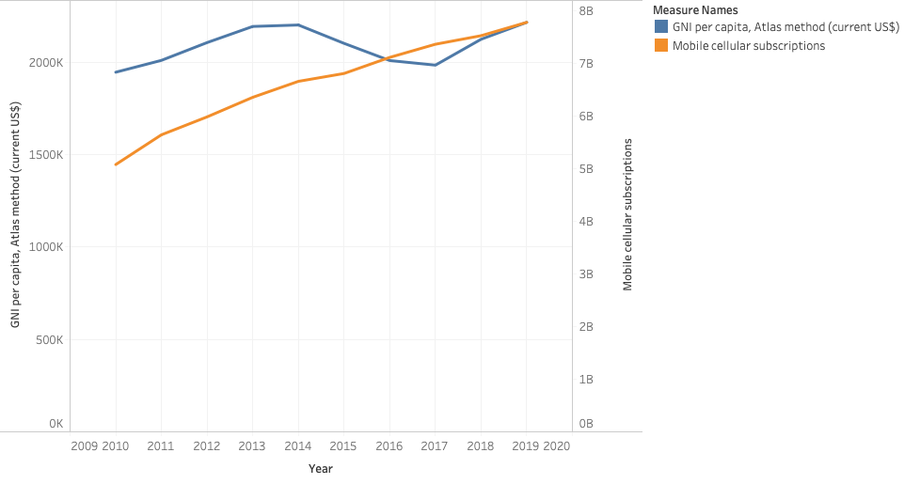

Figure 10 Dual lines of Mobile Cellular Subscriptions and GNI per capita - Wanshan Mao

* Figure 10 displayed a dual lines chart where x-axis represents year, y-axis represents values, where blue line represented GNI per capita and orange line represented mobile cellular subscription.
* The chart indicated that the total number of mobile cellular subscriptions increased in 2009-2014 as GNI per capita increased. During 2014 and 2017, mobile cellular subscriptions increased as GNI per capita decreased. Therefore, it was hard to predict the trend of GNI per capita based on mobile cellular subscription.
* The findings suggested that a country should not focus on mobile cellular subscriptions if they wanted an estimated number of GNI per capita.

Figure 11 Side by side circles chart of Mobile Cellular Subscription and GNI per capita - Wanshan Mao

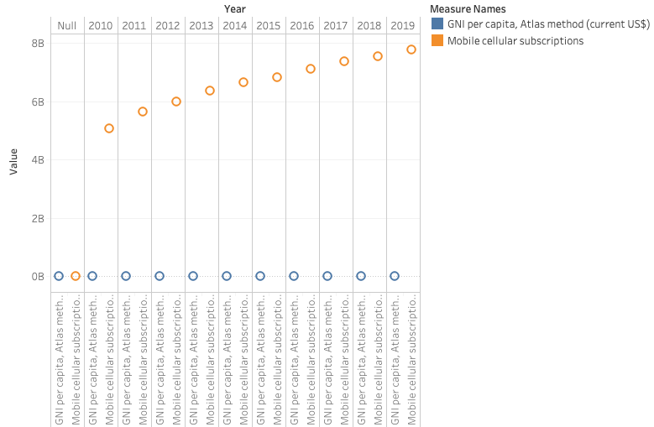

Figure 11 Side by side circles chart of Mobile Cellular Subscription and GNI per capita - Wanshan Mao

* Figure 11 displayed a side by side circle where the x-axis represented year and y-axis represented GNI per capita and mobile cellular subscriptions value. Blue circle represented GNI per capita and orange represents mobile cellular subscriptions.
* The chart indicated that mobile cellular subscriptions stayed relatively stable, as GNI per capita increased. Therefore, there was no significant relationship between mobile cellular subscriptions and GNI per capita.
* The findings suggested that a country should not focus on promoting mobile cellular subscriptions if they wanted an increase in GNI per capita.

Figure 12 Dual Combination of Individual using Internet and GDP per capita- Wanshan Mao

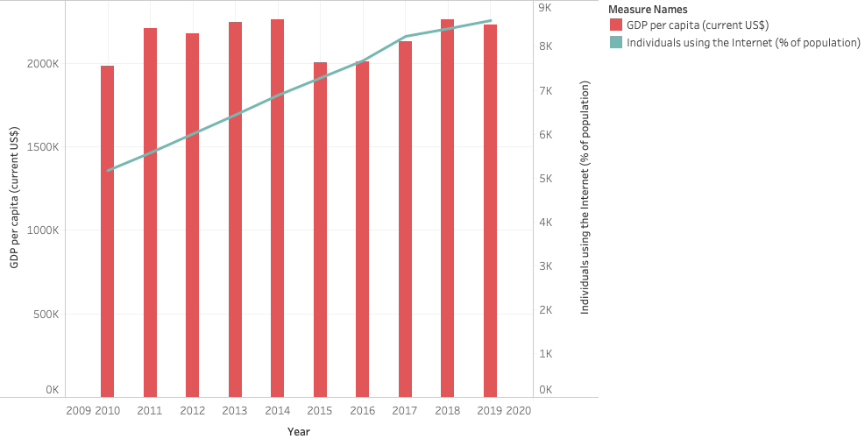

Figure 12 Dual Combination of Individual using Internet and GDP per capita - Wanshan Mao

* Figure 12 displayed a dual combination chart showing the relationship between individuals using the Internet and GDP per capita by year, where x-axis represented year and y-axis represented values.
* The chart indicated that there was a positive relationship between individuals using the Internet and GDP per capita, as the percentage of individuals using the internet, the number of GDP per capita increased correspondingly.
* The findings suggested that GDP per capita can be predicted by the percentage of individuals using the Internet. So a country could predict the trend of their GDP per capita per year based on individuals using the internet.

Figure 13 Horizontal bar chart of Individuals using the Internet and GDP per capita by country name - Wanshan Mao

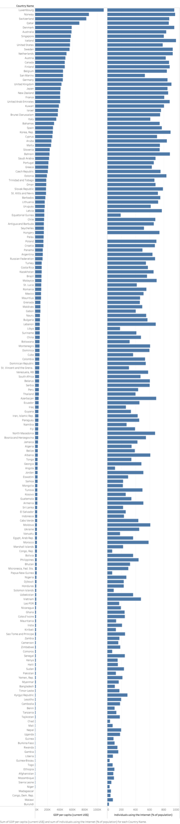

Figure 13 Horizontal bar chart of Individuals using the internet and GDP per capita by country name - Wanshan Mao

* Figure 13 displayed a horizontal bar where the left bar represented GDP per capita by country and the right bar represented individuals using the internet by country.
* The chart indicated that as individuals using the internet, GDP per capita decreased as well.
* The findings suggested that a country with a higher number of individuals using the internet had a higher GDP per capita. So if a country wanted to increase GDP per capita, they could encourage people using the Internet more actively.

Figure 14 Tree Map of Average Secure Internet Server and Average Unemployment total -Yuge Ma

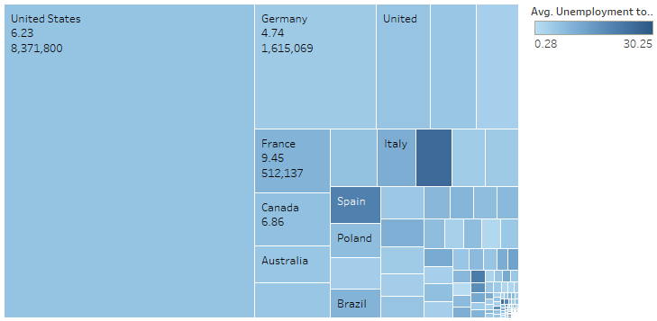

Figure 14 Tree Map of Average Secure Internet Server and Average Unemployment total -Yuge Ma

* Figure 14 displayed a tree map where the color represented average school enrollment and the size represented the average secure internet server.
* The chart indicated that the results were mixed, but on average, there was a negative correlation between average secure internet servers and average unemployment total.
* The findings suggested more secure internet servers, the less unemployment rate, which could be explained by if a country had enough secure internet servers, the online transactions would be faster, more information would be transferred, and more job opportunities would be available.

Figure 15 Symbol map of average percentage of individuals using the Internet and average percentage of school enrollment -Yuge Ma

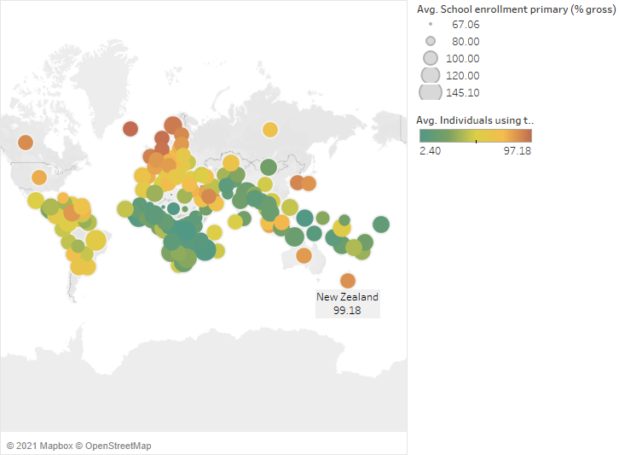

Figure 15 Symbol map of average percentage of individuals using the Internet and average percentage of school enrollment -Yuge Ma

* Figure 15 displayed a Symbol Map chart where it showed each country’s real longitude and latitude in the map: the size of each circle represented average school enrollment, the color represented average individuals using the Internet.
* The chart on average, indicated a positive correlation between the average individuals using the Internet and percentage of school enrollment. In other words, as average individuals using the Internet increased, the school enrollment increased.
* The findings suggested that education was strongly linked to technology development. The government should focus on both education and technology development in order to achieve both improvement.

Figure 16 Dual Line Chart of Computer communication and other services and Unemployment total in 10 year time frame -Yuge Ma

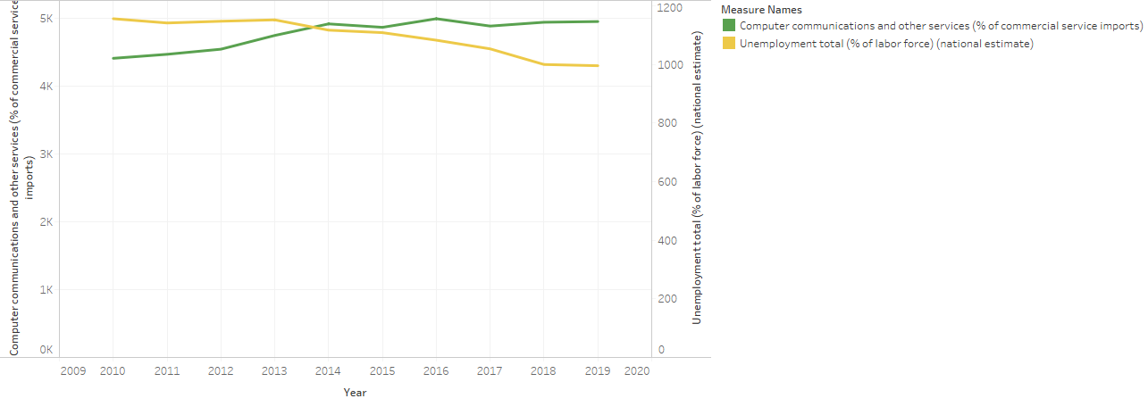

Figure 16 Dual Line Chart of Computer communication and other services and Unemployment total in 10 year time frame -Yuge Ma

* Figure 16 displayed a dual line chart, which showed the relationship between computer communication and other services and unemployment rate in total population by year, where x-axis represented year and y-axis represented values. The green line represented computer, communication and other services, while the yellow line represented unemployment total.
* The chart indicated that there was a negative relationship between Computer communications and other services and Unemployment total. As shown on the chart, mostly when the green line increased, the yellow line decreased.
* The findings suggested that Computer, communication and other services include miscellaneous business, which determined the amount of online trades. Based on this chart, it indicated that computers, communication and other services could bring more job opportunities to a country. So world leaders should encourage more computer, communications and other services, which would bring down the unemployment rate.

Figure 17 Area chart of Fixed Broadband Subscriptions and GNI per capita - Owakhela Kankhwende

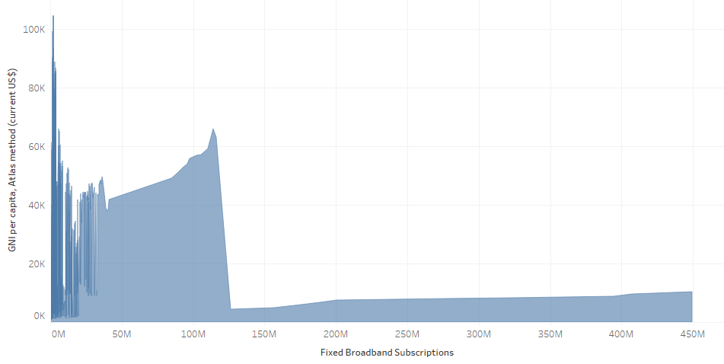

Figure 17 Area chart of GNI per capita and Fixed Broadband Subscriptions - Owakhela Kankhwende

* Figure 17 Depicted Fixed Broadband Subscriptions on the X axis with GNI per Capita on the Y axis.
* The figure showed an overall decline in GNI per Capita as Fixed Broadband Subscriptions increased, marked by steep drop offs twice in the series.
* The findings suggested that Fixed Broadband Subscriptions was negatively associated with GNI per Capita, marked by most of the observations being in a relatively small range within the scope of the whole data series.

Figure 18 Symbol map bar chart of Individuals using the Internet and Current Healthcare Expenditure by Country - Owakhela Kankhwende

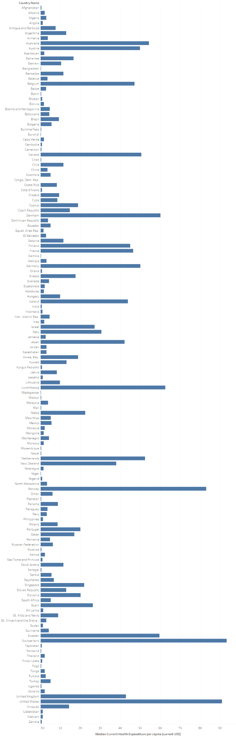

Figure 18 Symbol map bar chart of Individuals using the Internet and Current Healthcare Expenditure, by Country - Owakhela Kankhwende

* Figure 18 displayed two variables of Individuals using the Internet and Current Healthcare Expenditure on the X axis, and all countries in the dataset on the Y axis.
* The figure did not depict an easily identifiable relationship between the two variables.
* The insight gained despite the lack of an easily identifiable relationship was once again of Current Healthcare Expenditure being notably different amongst various countries, suggesting many factors not covered in the study.

Figure 19 Bubble Chart of Mobile Cellular Subscriptions and Current Healthcare Expenditure - Owakhela Kankhwende

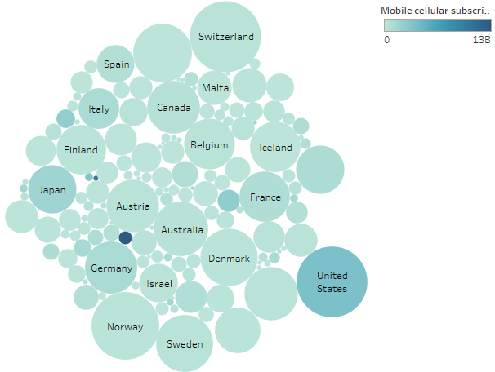

Figure 19 Bubble chart of Mobile Cellular Subscriptions and Current Healthcare Expenditures, by country name - Owakhela Kankhwende

* Figure 19 displayed a bubble chart where the color represents the mobile cellular subscriptions and the size of each circle represents the average current health expenditure.
* The chart did not detail a very strong associative relationship between the two variables across a significant number of countries.
* The insight gained was that Current Healthcare Expenditure is notably different from country to country although we could not find an associative link between the variables.

Figure 20 Side by side of Computer communication and other services and School enrollment primary - Wanshan Mao

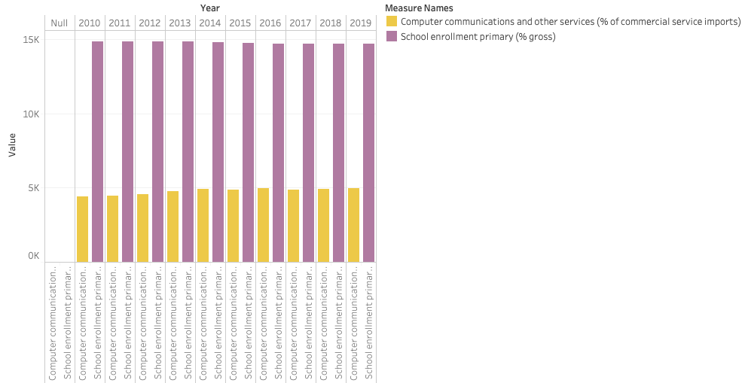

Figure 20 Side by side of Computer communication and other services and School enrollment primary

* Figure 20 displayed a side by side chart where purple bar represented school enrollment and yellow bar represented computer communication and other services.
* The figure indicated that there was no significant relationship between computer communication and other services and school enrollment.
* The findings suggested that a country does not need to focus on computer communication and other services if they want to increase the school enrollment primary rate.

Figure 21 Multiple Regression model of Fixed Broadband Subscriptions, Fixed Telephone Subscriptions and Mobile Cellular Subscriptions effect on GDP per Capita - Owakhela Kankhwende

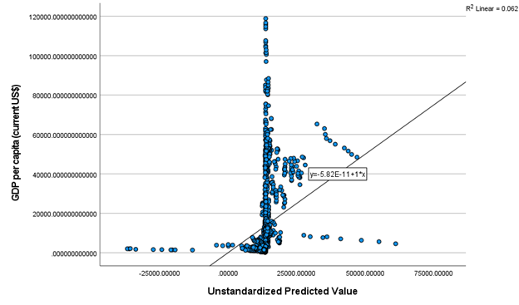

Figure 21 Multiple Regression model of Fixed Broadband Subscriptions, Fixed Telephone Subscriptions and Mobile Cellular Subscriptions effect on GDP per Capita - Owakhela Kankhwende

* Figure 21 displayed a multiple regression model detailing the chosen independent variable’s predicted values vs the actual values of GDP per Capita
* The Pearson Correlation Figures detailing small positive Pearson correlation between Fixed Broadband Subscriptions and GDP per capita as well as Fixed Telephone Subscriptions. Mobile Cellular Subscriptions had a smaller negative Pearson correlation. However the p-values detailed that the Coefficients for each of the Independent variables were statistically significant from 0 and contribute to the model, albeit at relatively smaller levels than we would like in order to consider them strong predictors.
* The independent variables in the model do have a relationship with GDP per Capita, but the strength in this relationship likely lies in a descriptive link to be covered in our charts rather than a predictive link.

|  |  |  |  |  |
| --- | --- | --- | --- | --- |
| **Pearson Correlation** | GDP per Capita | Fixed Broadband Subscription | Fixed Telephone Subscription | Mobile Cellular Subscription |
| GDP per Capita | 1.000 | 0.103 | 0.144 | -0.018 |
| Fixed Broadband Subscription | 0.103 | 1.000 | 0.849 | 0.792 |
| Fixed Telephone Subscription | 0.144 | 0.849 | 1.000 | 0.762 |
| Mobile Cellular Subscription | -0.018 | 0.792 | 0.762 | 1.000 |

|  |  |  |
| --- | --- | --- |
|  | Standardized Coefficients Beta | P value |
| Fixed Broadband Subscription | 0.109 | 0.023 |
| Fixed Telephone Subscription | 0.312 | 0.000 |
| Mobile Cellular Subscription | -0.342 | 0.000 |

Figure 22 K-Means model of Individuals using the Internet and GDP per capita by using SPSS- Yuge Ma

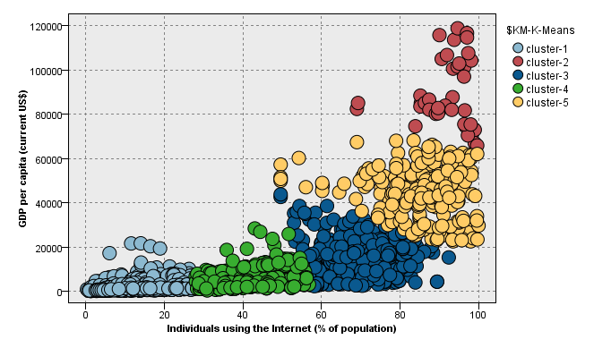

Figure 22 K-Means model of Internet using the Internet and GDP per capita -Yuge Ma

* Figure 22 displayed a statistical model of Individuals using the Internet and GDP per capita, where the x axis showed individuals using the Internet, and the y axis showed GDP per capita.
* The chart indicated that there was a positive relationship between individuals using the Internet and GDP per capita. By using K means clustering, all the countries were divided into 5 clusters:

|  |  |  |  |
| --- | --- | --- | --- |
| Cluster # | Size | Individuals Using the Internet | GDP per capita |
| 1 | 34.6% | 13.29 | 2189.28 |
| 2 | 25.4% | 42.01 | 6265.94 |
| 3 | 24.2% | 68.77 | 13955.44 |
| 4 | 13.8% | 85.10 | 44508.65 |
| 5 | 2.1% | 91.92 | 89765.87 |

* The finding suggested that if more people use the Internet, it would boost the GDP. The reason behind this might be by using the Internet, there would be more job opportunities, and the online transaction would boost the GDP as well.